

Service Level
Agreement



Administrative Support Services

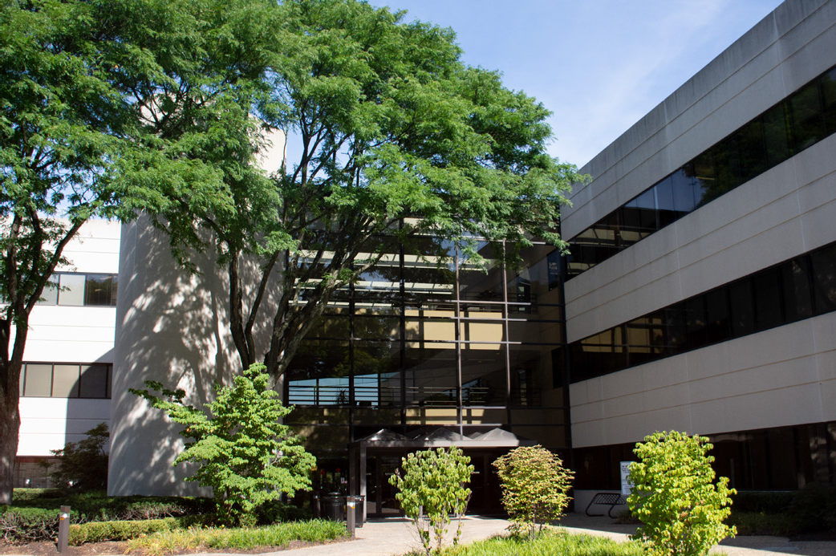

July 1, 2026

TABLE OF CONTENTS

1.0 Service Level Agreement Overview 1
2.0 Description of Services 1
3.0 Service Costs 1
4.0 Service Provider Responsibilities 1
5.0 Problem Management 3
6.0 Key Performance Indicators and Metrics 4
7.0 Periodic Review Process 4
8.0 Out of Scope Services 5

1.0 SERVICE LEVEL AGREEMENT OVERVIEW

This Service Level Agreement (SLA) is intended to identify the basic services, and any agreed upon optional services provided by the Administrative Support Services group, a unit within Business Services of Institutional Planning and Operations. Administrative Support Services provides a host of services to the departments/units which fall under the Institutional Planning and Operations’ (IP&O) divisional umbrella. They are responsible for coordinating and uniting the administrative (budget, finance, accounting, IT and labor relations) support of IP&O.

This SLA covers the period from July 1, 2026 - June 30, 2027, and will be reviewed and revised at the end of this period.

2.0 DESCRIPTION OF SERVICES

Administrative Support Services group is responsible for coordinating and uniting the efforts of IP&O individual units statewide. The unit provides data that drives decisions about business efforts, as well as aiding in future planning. Oversees budget, finance, accounting, timekeeping, IT and labor relations support. Administrative Support Services are a team of professionals committed to the delivery of innovative, effective and efficient customer services while maintaining fiscal integrity.

- SERVICE COSTS

Note: “General and Administrative” RCM Metric uses operating expenses to allocate the cost pool. Exclusions include: direct debt, direct utilities, F&A return, and subcontracts.

In developing the fiscal operating budget (Cost Pool), there are numerous assumptions and sensitivities that are addressed. These include but are not limited to:
    - Changes in aligned employees collective bargaining agreements.
    - Fluctuation in fringe benefit rates.
    - Rise in contract, equipment and supply costs.

- SERVICE PROVIDER RESPONSIBILITIES

Administrative Support Services is a diverse group of professionals providing valued services to IP&O. We strive for outstanding service delivery, innovation and continuous improvements.

Financial Governance
    - Managing the fiscal affairs of the unit within the IP&O Division
    - Providing business related guidance to unit’s staff
    - Serving as the unit’s primary contact with numerous divisions of the central University, including:
      - the Office of Budget
      - the Office of the Controller
      - Research Financial Services
      - the Payroll Department
      - and other Rutgers business offices
    - Improving internal controls
    - Enhancing reporting and finance related services
    - Reducing costs across the division

Financial Services
    - Overseeing general accounting activities and authorizations (signatory authority, journal entries, new accounts, etc.)
    - Managing approval of salary and non-salary expenditures
    - Initiating and Analyzing Financial Reports (monthly, quarterly, year-end and ad-hoc)
    - Monitoring Accounts Payable and Accounts Receivables
    - Maintaining Chart of Accounts

Budget Services
    - Budget Development
    - Budget Adjustments
    - Forecasting
    - Workforce Planning
    - Budget to Actual Analysis and Reporting
    - RCM Modeling

Procurement Services
    - Strategic Sourcing
    - Requisition and Purchase Order Processing/Approval
    - Invoice Payments Processing/Approval
    - RFP and RFI Development
    - Bidding Process

Timekeeping
    - Kronos Administration

Information Technology Service
    - Application Development
    - Data Administration
    - Server Administration
    - Desktop Support
    - Enterprise Software Support/Management

      - Help Desk Support
      - Systems Administration
      - Web Development/Programming

Labor Relations
      - Providing advice to IP&O units and supervisors with respect to interpretation and application of university Human Resource policies and university bargaining agreements.
      - Providing support and training to supervisors with respect to discipline.
      - Administering the grievance process for IP&O
        - Managing the scheduling of grievance hearings
        - Providing guidance to supervisors on how to present information and preside over hearings during the grievance process.
      - Serving as a liaison to the Office University Labor Relations for grievances and other related matters.
      - Facilitating compliance with certain Federal and State laws related to employment
      - Supports the Office University Labor Relations on Negotiating, administering and interpreting the collectively negotiated agreements with staff labor unions

5.0 PROBLEM MANAGEMENT

Administrative Support Services operates collaboratively within our group, as well as with colleagues from other internal IP&O departments and outside of IP&O. Should problems arise, the contacts listed below are equipped to manage the issues. Should problems be unresolved, their resolution will be escalated to the Vice President.

5.1 SUPPORT & PROBLEM ESCALATION CONTACT LIST

Support Help Line
Name | Role | Phone | Email
Business Email | General Email Box | 848-932-1011 | business.services@ipo.rutgers.edu
Support Contacts
Erin Cuomo | AVP Budget and Finance | 848-932-4981 | erin.cuomo@rutgers.edu
Gerald Thomas | Senior Director, Capital Budget and Finance | 848-445-2804 | gerald.thomas@rutgers.edu

Name | Role | Phone | Email
Edward Fabula | Executive Director, Information Technology | 848-932-2552 | edward.fabula@rutgers.edu
Leslie Reyes | Assistant Director Labor Relations | 848-445-2546 | Leslie.s.reyes@rutgers.edu
Jennifer Sousa | Assistant Director Administration | 848-445-3715 | Jennifer.sousa@rutgers.edu
Escalation Contacts
Name | Role | Phone | Email
Henry X. Velez | Vice President, Business Services | 848-932-1011 | henry.x.velez@rutgers.edu

- KEY PERFORMANCE INDICATORS AND METRICS

    - Operating expense ratio
    - Forecast budget to actual variances
    - Cost recovery ratio
    - Up-time of information systems
    - Active to budgeted employee FTEs

7.0 PERIODIC REVIEW PROCESS

This SLA is a living document and will be reviewed and updated at a minimum of once per fiscal year. Contents of this document may be amended as required, provided mutual agreement is obtained and communicated to all affected parties. Administrative Support Services will incorporate all subsequent revisions and obtain mutual agreements/approvals as required.

- OUT OF SCOPE SERVICES

Out of scope services are those services specific to accomplish a goal within a school or department. These services are fee based. Order of Magnitude estimates are provided upon request. Service examples include:

    - Kronos installation and support services
    - Shared IT licenses
    - Agreed upon support services



SUPPORTING TODAY, ENVISIONING TOMORROW.

