

Service Level
Agreement

Rutgers Environmental Health and Safety (REHS)

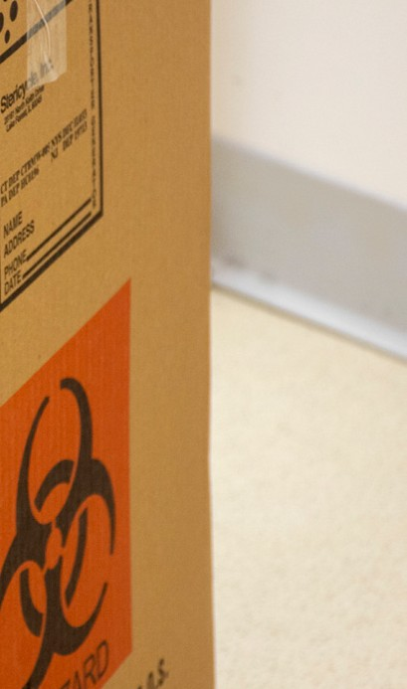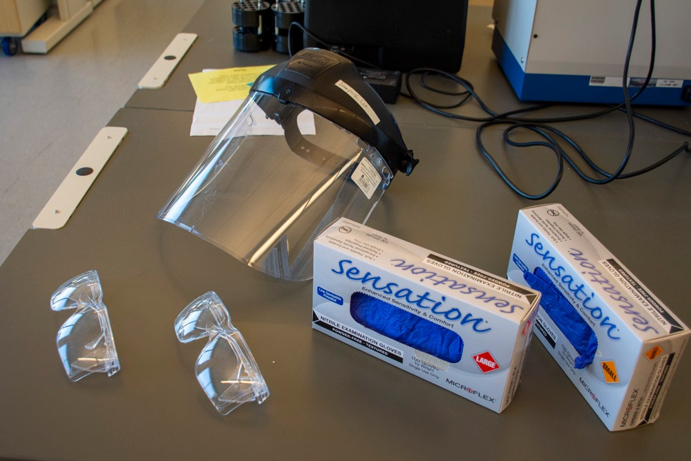


July 1, 2026

TABLE OF CONTENTS

1.0 Service Level Agreement Overview 1
2.0 Description of Services 1
3.0 Service Costs 1
4.0 Service Provider Responsibilities 2
5.0 Problem Management 2
6.0 Key Performance Indicators and Metrics 3
7.0 Periodic Review Process 3
8.0 Out of Scope Services 3

1.0 SERVICE LEVEL AGREEMENT OVERVIEW

This Service Level Agreement (SLA) is intended to identify the basic services, and any agreed upon optional services provided by Rutgers Environmental Health and Safety (REHS).

This SLA covers the period from July 1, 2026 - June 30, 2027, and will be reviewed and revised at the end of this period.

- DESCRIPTION OF SERVICES

REHS provides comprehensive professional services to the university community to ensure a safe and healthy environment by protecting people, property, the environment and promoting compliance.

Service areas include: Occupational Health and Safety; Research Support (radiation, biological, chemical, and physical); Environmental Stewardship; Hazardous Materials Management; and Clinical & Health Care Support.

Service/Product Delivered:

    - Development, implementation and auditing of programs, policies and procedures
    - Consultations, assessments and inspections
    - Education, training and outreach programs
    - Risk and liability mitigation
    - Regulatory compliance assistance and liaison with regulatory agencies
    - Hazardous waste services
    - Emergency response
    - Participation with various internal/external committees

- SERVICE COSTS

Note: “Research Support” RCM Metric uses modified expenses based on Grant and Contract Accounting’s (GCA) modified total direct cost (MTDC) policy for grants to allocate the cost pool. Exclusions include: clinical contracts.

In developing the fiscal operating budget (Cost Pool), there are numerous assumptions and sensitivities that are addressed. These include but are not limited to:
    - Changes in aligned employees collective bargaining agreements.
    - Fluctuation in fringe benefit rates.
    - Rise in contract, equipment and supply costs.
    - State and Federally mandated regulatory requirements

- SERVICE PROVIDER RESPONSIBILITIES

    - Health and Safety Services: Provide comprehensive professional services to the university community to ensure a safe and healthy environment for all employees, students and visitors, including response to complaints/concerns, consultation, workplace assessments/audits and regulatory compliance assistance.
    - Research/Laboratory Services: Provide comprehensive professional services that supports the research community including consultation, review of research activities (granting/funding/committees), assessments/audits, and regulatory compliance assistance.
    - Clinical and Healthcare Services: Provide comprehensive professional services that supports the university clinical and healthcare operations including consultation, review of exposure control plans, perform assessments/audits, investigate exposure and needlestick incidents, participate in accreditation efforts, and provide regulatory compliance assistance.
    - Emergency Response Services: Provide immediate emergency response to the university community, with respect to emergencies involving chemical, radiological, biological, and health/safety concerns, to protect lives, property, the environment, and to minimize potential liabilities and impacts to business continuity.
    - Hazardous Waste Management Services: Provide comprehensive professional services to the university with the collection, transportation, disposal and recordkeeping services for all hazardous waste (chemical, medical, universal, e-waste) in a regulatory compliant and socially responsible manner.
    - Environmental Services: Provide comprehensive professional services to the university community to mitigate environmental impacts and liabilities for all university properties, including consultation, assessments/audits, site remediation, and regulatory compliance assistance.
    - Employee Immunization and Administrative Compliance: Provide compliance oversight for required immunizations including tracking compliance status, compliance reporting, processing waiver requests, approving immunization, recording declinations and/or documentation, notifications to employees, training, and working with key teams to review, assess and resolve non-compliance concerns. Provide administrative support and regulatory reporting for various programs areas (i.e. CDLs, RTK, respiratory protection, lead-based paint, etc.)
    - Training: Create, provide, and track environmental, health and safety training courses for faculty, staff and students. Courses focus on promoting a safe work environment by ensuring regulatory compliance and providing requisite knowledge to perform work safely.

5.0 PROBLEM MANAGEMENT

All issues are directed to the appropriate program manager. The program manager will address the issue(s) by coordinating a response with all applicable parties. Significant or unresolved issues will be raised to the Executive Director.

5.1 SUPPORT & PROBLEM ESCALATION CONTACT LIST

Support Help Line
Name | Role | Phone | Email
REHS Central Office | Administrative | 848-445-2550 | rehs@rutgers.edu
Support Contacts
Name | Role | Phone | Email
Alejandro Ruiz | Executive Director | 848-445-2550 | alex.ruiz@rutgers.edu
Mark McLane | Assistant Vice President | 848-445-2550 | mark.mclane@rutgers.edu
Escalation Contacts
Mark McLane | Assistant Vice President | 848-445-2550 | mark.mclane@rutgers.edu

- KEY PERFORMANCE INDICATORS AND METRICS

    - University Incident Rate
    - Workers Compensation Experience
    - Results of Regulatory Inspections/compliance
    - Results of audits
    - Efficiency of protocol reviews and approvals

7.0 PERIODIC REVIEW PROCESS

This SLA is a living document and will be reviewed and updated at a minimum of once per fiscal year. Contents of this document may be amended as required, provided mutual agreement is obtained and communicated to all affected parties.

- OUT OF SCOPE SERVICES

    - Asbestos abatement, sampling for projects, renovations
    - Asbestos abatement for auxiliary operations
    - Environmental contamination/issues for construction projects or property acquisition/transfer
    - On-going environmental registrations, permits and sampling for deed restricted properties or site contamination
    - Regulatory penalties/fines for violations issued from compliance inspections
    - Laboratory moves/relocations of hazardous materials and equipment (internal and external)

- Requirements for departmental/individual permits (i.e. licensing requirements for daycare centers, CAPS accreditations, etc.)
- Services provide to University Hospital (separate agreement)
- Biological safety cabinet certification for Rutgers Health units. Repair of cabinets all units
- Radiation safety services (staffing, overhead) provided to RWJMS, CABM and CINJ
- Survey costs (except environmental surveys), registration fees, and renewal fees for machine sources of ionizing radiation for clinical operations
- Hazardous materials clean up/disposal as the result of poor management practices
- Non-regulatory, non risk-based requested sampling

Billable rates will be based on labor hourly rates plus material. The labor rate will be established each year. The service unit will provide an estimate of costs to the requesting unit and the requesting unit will issue an internal purchase order or transfer funds based on the estimate prior to the service unit commencing the work. A final invoice will be issued at the end of the work.

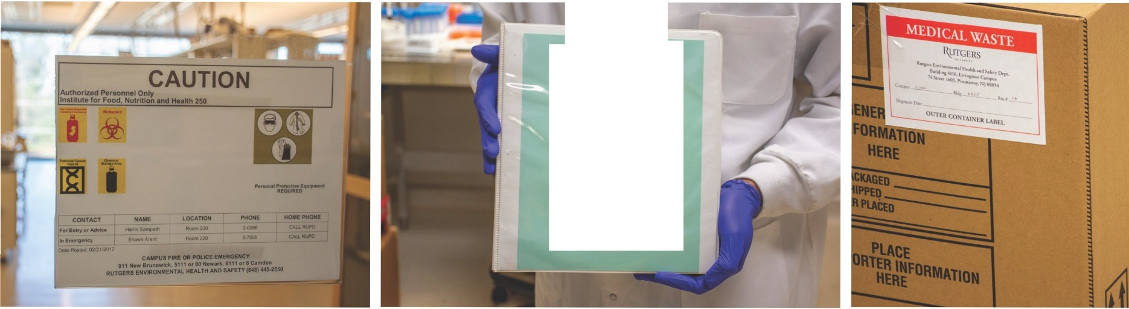

CHEMICAL HYGIENE GUIDE
.... ............._

SUPPORTING TODAY, ENVISIONING TOMORROW.

