Standard Operating Procedure for Laboratories

FORMALDEHYDE

Department: | Click here to enter text.
Principal Investigator(s): | Click here to enter text.
Lab Manager/Coordinator: | Click here to enter text.
Location of Experiment:  (Building/Room Number) | Click here to enter text.
Lab Phone: | Click here to enter text.
Office Phone: | Click here to enter text.
Emergency Contact: (Name/Phone) | Click here to enter text.

Reviewed and Approved by:

PI: (Typed Name) | Click here to enter text.
PI: (Signature and Date) |  | Click here to enter a date.
Lab Manager: (if PI unavailable) |  | Click here to enter a date.

Hazardous Material Use and Management

Hazardous Material(s) Used: (wt./volume) | Formaldehyde:  Maximum amount allowed without PI approval:
Hazardous Material Storage Location: | Store container tightly closed in a dry, cool and well ventilated place.  Store away from acids, bases, reducing agents, metals, metal salts, halogens, combustible materials, peroxides, oxidizing materials. Store in flammable storage cabinet.  Designated Storage Area:
Experimental Procedure and Lab Technics to be Used: | Click here to enter text.
Hazard Identification: (i.e., physical/health hazards) | CAS # 50-00-0  GHS Classification: Flammable liquid. Acutely toxic by inhalation, ingestion or skin absorption. Skin sensitizer. Carcinogen. Acute aquatic toxicity.  - Confirmed carcinogen.  - Poison by ingestion. If inhaled can cause pulmonary dysfunction. Skin and eye irritant. Frequent or prolonged skin exposure can cause dermatitis or even eczema.  - React vigorously with oxidizers.  - Moderately explosive when exposed to heat or flame. When aqueous formaldehyde solutions heated above their flush point, a potential for explosion exists. Addition of methanol or higher concentration of formaldehyde will lower the flush point.  - Reacts violently with perchloric acid, and aniline, performic acid, nitromethane, magnesium carbonate and water. When heated to decomposition it emits acrid smoke and fumes.  OSHA PEL: TWA 0.75ppm, STEL 2ppm  ACGIH TLV: CL 0.3ppm, sensitizer, suspected human carcinogen  NIOSH REL: TWA 0.016ppm, CL 0.1ppm  Review MSDS/SDS prior to working with chemical.
Engineering Controls: (chemical fume hood, biosafety cabinet, glove box) | Work only in a chemical fume hood with adequate exhaust ventilation or ducted Biosafety cabinet. Eyewash and safety shower must be readily available.
Protective Equipment: | Handle with nitrile or chloroprene gloves  Wear tightly fitting safety goggles. Faceshield may be required.  Wear flame resistant lab coat, long pants and closed -toe shoes.  Check with glove manufacturer for more info.
Waste Collection/Disposal Method: | Waste should be collected in tightly closed container, in secondary containment and in a designated location inside a fume hood. Affix and complete hazardous waste label. Contact REHS for waste pick up. https://halflife.rutgers.edu/forms/hazwaste.php
Spill Management: | Wear respiratory protection. Avoid breathing vapors, mist or gas. Ensure adequate ventilation. Remove all sources of ignition. Evacuate personnel to safe areas. Beware of vapors accumulating to form explosive concentrations in low areas. Absorb the spill with inert material or collect it by wet brushing.  If a spill happened outside fume hood, on floor, on bench or outside the lab contact REHS for clean up or call 911.
First Aid: | Eyes: Flush eyes with warm water for 15 min. Consult a physician.  Skin: Flush affected skin with plenty of water and mild soap. Cover the contaminated skin with an antibacterial cream. Consult a physician.  Inhalation: Remove to fresh air. If breathing is difficult give oxygen. Consult a physician.  Ingestion: Rinse mouth with water. Consult a physician.

Training

- Prior to conducting any work with formaldehyde, designated personnel must be provided training specific to the hazard involved in working with the substance.
- The PI must provide his/her lab personnel with a copy of the SOP and a copy of the SDS provided with the manufacturer.
- The PI must ensure that his/her lab personnel have attended and are up to date on the appropriate laboratory safety training within the last year.

I have read and understood the content of this SOP and the SDS:

Lab Personnel  (Running the Experiment) | Date of Hands-on Training from Department | Signature of Lab Personnel
Click here to enter text. | Click here to enter text.
Click here to enter text. | Click here to enter text.
Click here to enter text. | Click here to enter text.

FORMALDEHYDE
Flammable liquid. Acutely toxic by inhalation, ingestion or skin absorption. Skin sensitizer. Carcinogen. Acute aquatic toxicity.
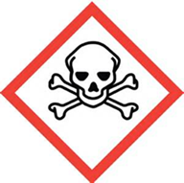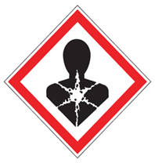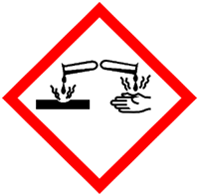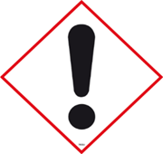
FIRST AID

Eyes: Flush eyes with warm water for 15 min. Consult a physician.
Skin: Flush affected skin with plenty of water and mild soap. Cover the contaminated skin with an antibacterial cream. Consult a physician.
Inhalation: Remove to fresh air. If breathing is difficult give oxygen. Consult a physician.
Ingestion: Rinse mouth with water. Consult a physician.

DIAL 911 Call REHS for more information 848-445-2550

