Standard Operating Procedure for Laboratories

ETHYLENIMINE

Department: | Click here to enter text.
Principal Investigator(s): | Click here to enter text.
Lab Manager/Coordinator: | Click here to enter text.
Location of Experiment:  (Building/Room Number) | Click here to enter text.
Lab Phone: | Click here to enter text.
Office Phone: | Click here to enter text.
Emergency Contact: (Name/Phone) | Click here to enter text.

Reviewed and Approved by:

PI: (Typed Name) | Click here to enter text.
PI: (Signature and Date) |  | Click here to enter a date.
Lab Manager: (if PI unavailable) |  | Click here to enter a date.

Hazardous Material Use and Management

Hazardous Material(s) Used: (wt./volume) | Ethylenimine:  Maximum amount allowed without PI approval:
Hazardous Material Storage Location: | Store container tightly closed in a dry and well ventilated place. Separated from acids, oxidants, food and feedstuffs. Store only if stabilized.  Designated Storage Area:
Experimental Procedure and Lab Technics to be Used: | Click here to enter text.
Hazard Identification: (i.e., physical/health hazards) | CAS # 151-56-4  GHS Classification: Flammable. Acutely toxic. Carcinogen.  - Confirmed human carcinogen.  - Poison by ingestion, skin contact, inhalation and intraperitoneal routs.  - A skin, mucous membrane and severe eye irritant. An allergic sensitized to skin. Can cause severe eye injury like necrosis of cornea.  - A very dangerous fire and explosion hazard when exposed to heat, flame or oxidizers.  - Polymerizes explosively in presents of acids.  - Reacts violently with aluminum chloride, acetic acid, acetic anhydride, etc. Reacts with chlorinated compounds to form explosive 1-chloroaziridine. Reacts with silver or its alloys to form explosive silver derivatives (e.g. silver solder).  OSHA: Carcinogen  NIOSH: Carcinogen  Review MSDS/SDS prior to working with chemical.
Engineering Controls: (chemical fume hood, biosafety cabinet, glove box) | Use in chemical fume hood with adequate exhaust.  Eyewash and safety showers must be readily available.
Protective Equipment: | Use chemical resistant gloves, heavy duty nitrile, viton or butyl gloves are sufficient. Wear safety glasses with side shields, face shield may be recommended. Wear flame resistant lab coat, long pants and closed-toe shoes.  Check with glove manufacturer for more info.
Waste Collection/Disposal Method: | Waste should be collected in tightly closed one-quart container, in secondary containment and in a designated location inside a fume hood. Affix and complete hazardous waste label. Contact REHS for waste pick up.  https://halflife.rutgers.edu/forms/hazwaste.php
Spill Management: | Evacuate danger area. Wear personal protective equipment. Remove all ignition sources. Collect leaking and spilled liquid in sealable containers as far as possible. Absorb remaining liquid in sand or inert absorbent and remove to safe place. Do not let it enter the environment. Self-contained breathing apparat may be required.  If a spill happened outside fume hood, on floor, on bench or outside the lab contact REHS for clean up or call 911.
First Aid: | Eyes: Flush eyes with warm water for 15 min. Seek medical attention.  Skin: Flush affected skin with plenty of water. Seek medical attention.  Inhalation: Remove to fresh air. If breathing is difficult give oxygen. Seek medical attention.  Ingestion: Rinse mouth with water. Drinking of carbonated beverages is recommended as an antidote. Seek medical attention.

Training
- Prior to conduct any work with ethylenimine, designated personnel must be provided training specific to the hazard involved in working with the substance.
- The PI must provide his/her lab personnel with a copy of the SOP and a copy of the SDS provided with the manufacturer.
- The PI must ensure that his/her lab personnel have attended and are up to date on the appropriate laboratory safety training within the last year.

I have read and understood the content of this SOP and the SDS:

Lab Personnel  (Running the Experiment) | Date of Hands-on Training from Department | Signature of Lab Personnel
Click here to enter text. | Click here to enter text.
Click here to enter text. | Click here to enter text.
Click here to enter text. | Click here to enter text.

ETHYLENIMINE
Flammable. Acutely toxic. Carcinogen.

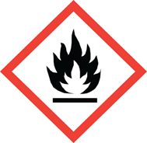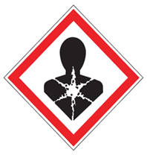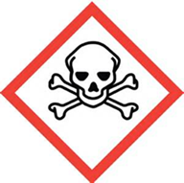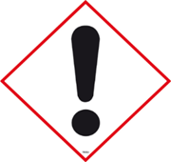
FIRST AID

Eyes: Flush eyes with warm water for 15 min. Seek medical attention.
Skin: Flush affected skin with plenty of water. Seek medical attention.
Inhalation: Remove to fresh air. If breathing is difficult give oxygen. Seek medical attention.
Ingestion: Rinse mouth with water. Drinking of carbonated beverages is recommended as an antidote. Seek medical attention.

DIAL 911 Call REHS for more information 848-445-2550

