Standard Operating Procedure for Laboratories

CYANIDE SALTS

Department: | Click here to enter text.
Principal Investigator(s): | Click here to enter text.
Lab Manager/Coordinator: | Click here to enter text.
Location of Experiment:  (Building/Room Number) | Click here to enter text.
Lab Phone: | Click here to enter text.
Office Phone: | Click here to enter text.
Emergency Contact: (Name/Phone) | Click here to enter text.

Reviewed and Approved by:

PI: (Typed Name) | Click here to enter text.
PI: (Signature and Date) |  | Click here to enter a date.
Lab Manager: (if PI unavailable) |  | Click here to enter a date.

Hazardous Material Use and Management

Hazardous Material(s) Used: (wt./volume) | CYANIDE SALTS:  Maximum amount allowed without PI approval:
Hazardous Material Storage Location: | Store in a dry, cool and well-ventilated place. Keep container tightly closed. Store away from acids and combustible material and protected from moisture.  Designated Storage Area:
Experimental Procedure and Lab Techniques to be Used:
Hazard Identification: (i.e., physical/health hazards) | CAS #143-33-9; 151-50-8  GHS Classification: Corrosive to metals, fatal if swallowed, in contact with skin, or if inhaled. Cause damage to organs if swallowed or through prolonged or repeated exposure. Very toxic to aquatic life.  - Volatile cyanides are more toxic due to a possibility of inhalation of high doses in short time. Death can occur in minutes.  - Cyanides inhibits tissue oxidation causing death though asphyxia.  - Some cyanide salts may easily decompose to hydrogen cyanide (HCN) flammable gas that is highly toxic.  Caution needs to be taken when opening containers.  Review MSDS/SDS prior to working with chemical.
Engineering Controls: (chemical fume hood, biosafety cabinet, glove box) | Always use chemical fume hood with adequate ventilation when handling cyanides. Make sure that all equipment is grounded.  Safety shower and eye wash must be easily accessible.
Protective Equipment: | When Permissible Exposure Limit (PEL) is exceeded, the use of full face respirator is required by regulation. Contact REHS for more information.  Nitrile gloves are sufficient for most cyanide salts, but always check glove compatibility for particular cyanide salt you plan to use. Wear properly fitting safety glasses or chemical splash goggles. Faceshield is recommended.  Wear full length lab coat with long sleeves, long pants and closed-toe shoes.  Always check with glove manufacturer for more info.
Waste Collection/Disposal Method: | Store liquid cyanide salt waste in tightly closed one-quart container, in secondary plastic containment and in a designated location inside a fume hood. Double bag dry cyanide waste. Dispose empty glass containers as hazardous waste. Affix and complete hazardous waste label.  Contact REHS for waste pick up: https://halflife.rutgers.edu/forms/hazwaste.php
Spill Management: | Assess the spill for extent of danger, avoid breathing vapors or creating dust, ensure adequate ventilation. Help contaminated person, evacuate the spill area.  Only attempt to clean up a spill if you trained and have appropriate personal protective equipment. Double bag the spill waste, contact REHS for pick up.  If a spill happened outside fume hood, on floor, on bench or outside the lab contact REHS for clean up or call 911.
First Aid: | Speedy action is critical.  Eyes: Check and remove contact lenses. Immediately flush eyes with plenty of water for 15 minutes. Seek medical attention.  Skin: Flush skin with plenty of water while removing contaminated clothes. Seek medical attention.  Inhalation: Remove person to fresh air. If breathing is difficult, give oxygen. Seek medical attention.  Ingestion: Do not induce vomiting. Call Poison center, seek immediate medical attention.

Training

- Prior to conducting any work with cyanide salts, designated personnel must be provided training specific to the hazard involved in working with the substance.
- The PI must provide his/her lab personnel with a copy of the SOP and a copy of the SDS provided with the manufacturer.
- The PI must ensure that his/her lab personnel have attended and are up to date on the appropriate laboratory safety training within the last year.

I have read and understood the content of this SOP and the SDS:
Lab Personnel  (Running the Experiment) | Date of Hands-on Training from Department | Signature of Lab Personnel
Click here to enter text. | Click here to enter text.
Click here to enter text. | Click here to enter text.
Click here to enter text. | Click here to enter text.

CYANIDE SALTS

Fatal if swallowed, in contact with skin, or if inhaled. Cause damage to organs if swallowed or through prolonged or repeated exposure.

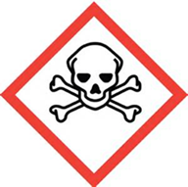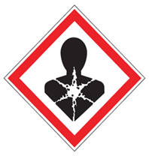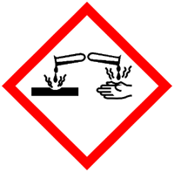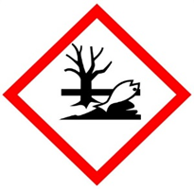

FIRST AID
Speedy action is critical.

Eyes: Check and remove contact lenses. Immediately flush eyes with plenty of water for 15 minutes. Seek medical attention.
Skin: Flush skin with plenty of water while removing contaminated clothes. Seek medical attention.
Inhalation: Remove person to fresh air. If breathing is difficult, give oxygen. Seek medical attention.
Ingestion: Do not induce vomiting. Call Poison center, seek immediate medical attention.

DIAL 911 Call REHS for more information 848-445-2550

