Standard Operating Procedure for Laboratories

CHLORINE

Department: | Click here to enter text.
Principal Investigator(s): | Click here to enter text.
Lab Manager/Coordinator: | Click here to enter text.
Location of Experiment:  (Building/Room Number) | Click here to enter text.
Lab Phone: | Click here to enter text.
Office Phone: | Click here to enter text.
Emergency Contact: (Name/Phone) | Click here to enter text.

Reviewed and Approved by:

PI: (Typed Name) | Click here to enter text.
PI: (Signature and Date) |  | Click here to enter a date.
Lab Manager: (if PI unavailable) |  | Click here to enter a date.

Hazardous Material Use and Management

Hazardous Material(s) Used: (wt./volume) | Chlorine:  Maximum amount allowed without PI approval:
Hazardous Material Storage Location: | Store away from direct sunlight in a dry, cool and well-ventilated area. Store locked up. Separate from acids, alkalies, reducing agents and combustibles. Store away from cylinders of hydrogen, acetylene, ammonia, fuel gases, ether, turpentine, hydrocarbons, organic matter or finely divided metals. Keep container tightly closed and sealed until ready for use. Cylinders should be stored upright, with valve protection cap in place, and firmly secured to prevent falling.  Designated Storage Area:
Experimental Procedure and Lab Techniques to be Used: | Lab must have written procedure for cylinder purge, setup and swap.
Hazard Identification: (i.e., physical/health hazards) | CAS # 7782-50-5  GHS Classification: Oxidizer, may cause or intensify fire. May cause frost bites. Fatal if inhaled. Corrosive to respiratory tract. Cause severe skin burns and eye damage. Very toxic to aquatic life.  - Acutely toxic.  - Oxidizer, reacts violently with combustible and reducing materials.  - Reacts explosively or forms explosive compounds with many common substances such as acetylene, ether, turpentine, ammonia, fuel gas, hydrogen & finely divided metals. The solution in water is a strong acid, it reacts violently with bases and is corrosive.  OSHA PEL: TWA 0.5ppm, CL 1ppm  ACGIH TLV: TWA 0.5ppm, CL 1ppm  NIOSH REL: CL 0.5ppm  Review MSDS/SDS prior to working with chemical.
Engineering Controls: (chemical fume hood, biosafety cabinet, glove box) | Use in chemical fume hood with adequate exhaust. A chlorine cylinder should never be directly connected to a vessel containing a liquid, since suckback may occur causing violent reaction within the cylinder.  Eyewash and safety showers must be readily available.
Protective Equipment: | Use nitrile or chloroprene gloves. Gloves must be inspected prior to use.  Wear safety glasses or goggles, sometimes use of a face shield may be required.  Wear full length lab coat to prevent skin exposure.  Check with glove manufacturer for more info.
Waste Collection/Disposal Method: | Store chlorine waste in tightly closed container, in secondary containment and in a designated location inside a fume hood. Store waste away from incompatible waste.  Affix and complete hazardous waste label.  Contact REHS for waste pick up:  https://halflife.rutgers.edu/forms/hazwaste.php
Spill Management: | Evacuate danger area. Shut off gas supply if this can be done safely. Isolate area until gas has dispersed. Self-contained breathing apparatus (SCBA) should be used to avoid inhalation of chlorine. Full chemical-resistant suit and self-contained breathing apparatus should be worn only by trained and authorized persons.  A solution of detergent and water with pH value 8 to 10.5 should be available for use in decontamination procedures.  Never direct water jet on liquid. Remove gas with fine water spray. Do not let this chemical enter the environment.  If a spill happened outside fume hood, on floor, on bench or outside the lab contact REHS for clean up or call 911.
First Aid: | Eyes: Flush eyes with plenty of water for 15 min. Seek immediate medical attention.  Skin: Flush skin with plenty of water for 15 min. remove contaminated clothing and shoes. Seek immediate medical attention.  Inhalation: move person to fresh air, if breathing is difficult give oxygen. Seek immediate medical attention.  Ingestion: As this product is a gas ingestion is not probable.

Training

- Prior to conducting any work with chlorine, designated personnel must be provided training specific to the hazard involved in working with the substance.
- The PI must provide his/her lab personnel with a copy of the SOP and a copy of the SDS provided with the manufacturer.
- The PI must ensure that his/her lab personnel have attended and are up to date on the appropriate laboratory safety training within the last year.

I have read and understood the content of this SOP and the SDS:
Lab Personnel  (Running the Experiment) | Date of Hands-on Training from Department | Signature of Lab Personnel
Click here to enter text. | Click here to enter text.
Click here to enter text. | Click here to enter text.
Click here to enter text. | Click here to enter text.

CHLORINE
May cause frost bites. Fatal if inhaled. Corrosive to respiratory tract. Cause severe skin burns and eye damage.

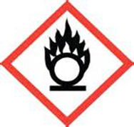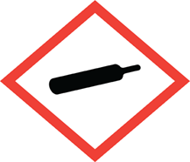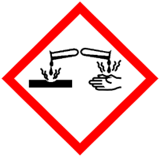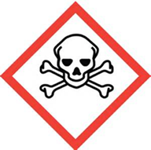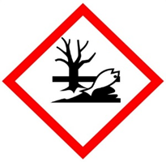

FIRST AID

Eyes: Flush eyes with plenty of water for 15 min. Seek immediate medical attention.
Skin: Flush skin with plenty of water for 15 min. remove contaminated clothing and shoes. Seek immediate medical attention.
Inhalation: move person to fresh air, if breathing is difficult give oxygen. Seek immediate medical attention.
Ingestion: As this product is a gas ingestion is not probable.

DIAL 911 Call REHS for more information 848-445-2550

