Standard Operating Procedure for Laboratories

BROMINE

Department: | Click here to enter text.
Principal Investigator(s): | Click here to enter text.
Lab Manager/Coordinator: | Click here to enter text.
Location of Experiment:  (Building/Room Number) | Click here to enter text.
Lab Phone: | Click here to enter text.
Office Phone: | Click here to enter text.
Emergency Contact: (Name/Phone) | Click here to enter text.

Reviewed and Approved by:

PI: (Typed Name) | Click here to enter text.
PI: (Signature and Date) |  | Click here to enter a date.
Lab Manager: (if PI unavailable) |  | Click here to enter a date.

Hazardous Material Use and Management

Hazardous Material(s) Used: (wt./volume) | BROMINE:  Maximum amount allowed without PI approval:
Hazardous Material Storage Location: | Store in a cool, dry, well ventilated area, away from drain or sewer access. Store only in original containers. Do not store in direct sunlight. Store in corrosive area. Avoid reducing agents, alkali metals, powdered metals, aluminum, stainless steel, iron organic materials, aldehydes, ketones, amines, phenols, ammonia, azides and ozone. Bromine will attack some types of plastic, rubber and coatings.  Designated Storage Area:
Experimental Procedure and Lab Techniques: | Lab must have written procedure for cylinder purge, set up and swap.
Hazard Identification: (i.e., physical/health hazards) | CAS# 7726-95-6  GHS Classification: Acutely toxic, corrosive, toxic to aquatic life, cause serious eye damage.  - Bromine is a strong oxidant, reacts violently with combustibles and reducing materials.  - React with most organic and inorganic compounds, causing fire and explosion hazard.  - Reacts explosively with metal azides and other metals.  - Bromine is corrosive to eyes, skin, respiratory tract. Corrosive on ingestion. Inhalation may cause asthma-like reactions, pneumonitis or may cause lung edema, all effects may be delayed.  OSHA PEL: TWA 0.1 ppm, (0.7mg/m3), STEL 0.3ppm,  ACGIH TLV 0.1 ppm, STEL 0.2ppm  NIOSH TWA: 0.1ppm, STEL 0.3ppm  Review MSDS/SDS prior to working with chemical.
Engineering Controls: (chemical fume hood, biosafety cabinet, glove box) | Use bromine in chemical fume hood with adequate exhaust.  Eyewash and safety showers must be readily available.
Protective Equipment: | Use neoprene, nitrile, fluorinated rubber gloves.  Tight-fitting safety googles. Face shield may be recommended.  Wear lab coat, long pants and closed-toe shoes.  Always check with glove manufacturer for more info.
Waste Collection/Disposal Method: | Store bromine waste in a tightly closed container, in secondary containment and in a designated location inside a fume hood. Store waste away from incompatible waste. Affix and complete hazardous waste label. Contact REHS for waste pick up:  https://halflife.rutgers.edu/forms/hazwaste.php
Spill Management: | The vapor is heavier than air. Evacuate danger area.  Wear gas-tight chemical protection suit including self-containing breathing apparatus. Do not let bromine enter environment or ventilation. Remove vapor with fine water spray. Collect leaking liquid in a sealable container with fluorinated coating. Do not absorb in a saw-dust or other combustible absorbents. Absorb remaining liquid in dry sand or inert absorbent and remove to safe place.  Is the spill occurred outside of a fume hood, lab bench, outside of the laboratory or on floor contact REHS for clean-up (848) 445-2550 or Dial 911.
First Aid: | Eyes: Check and remove contact lenses. Immediately flush eyes with warm water for 15 min. Seek medical attention.  Skin: Immediately flush skin with plenty of water. Cover irritated skin with emollient or anti-bacterial cream. Seek medical attention.  Inhalation: Remove to fresh air. If breathing is difficult give oxygen. Seek medical attention.  Ingestion: Do not induce vomiting. Get medical attention.

Training
- Prior to conducting any work with bromine, designated personnel must be provided training specific to the hazard involved in working with the substance.
- The PI must provide his/her lab personnel with a copy of the SOP and a copy of the SDS provided with the manufacturer.
- The PI must ensure that his/her lab personnel have attended and are up to date on the appropriate laboratory safety training within the last year.

I have read and understood the content of this SOP and the SDS:

Lab Personnel  (Running the Experiment) | Date of Hands-on Training from Department | Signature of Lab Personnel
Click here to enter text. | Click here to enter text.
Click here to enter text. | Click here to enter text.
Click here to enter text. | Click here to enter text.

BROMINE
Acutely Toxic, Corrosive, Toxic to Aquatic Life

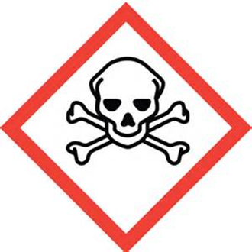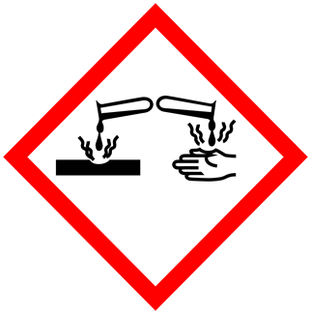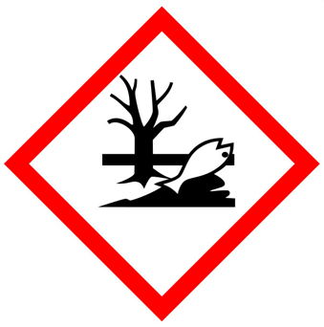

FIRST AID

Bromine is corrosive to eyes, skin, respiratory tract. Corrosive on ingestion. Inhalation may cause asthma-like reaction.

Eye Contact: Immediately flush eyes with warm water for 15 min. Seek medical attention.
Skin Contact: Immediately flush skin with plenty of water. Cover irritated skin with emollient or anti-bacterial cream. Seek medical attention.
Inhalation: Remove to fresh air. If breathing is difficult give oxygen. Seek medical attention.
Ingestion: Do not induce vomiting. Get medical attention

DIAL 911 Call REHS for more information 848-445-2550

