Standard Operating Procedure for Laboratories

Boron Trifluoride

Department: | Click here to enter text.
Principal Investigator(s): | Click here to enter text.
Lab Manager/Coordinator: | Click here to enter text.
Location of Experiment:  (Building/Room Number) | Click here to enter text.
Lab Phone: | Click here to enter text.
Office Phone: | Click here to enter text.
Emergency Contact: (Name/Phone) | Click here to enter text.

Reviewed and Approved by:

PI: (Typed Name) | Click here to enter text.
PI: (Signature and Date) |  | Click here to enter a date.
Lab Manager: (if PI unavailable) |  | Click here to enter a date.

Hazardous Material Use and Management

Hazardous Material(s) Used: (wt./volume) | Boron Trifluoride:  Maximum amount allowed without PI approval:
Hazardous Material Storage Location: | Store cylinders in a cool, dry well-ventilated gas cabinet. Protect from sunlight. Keep containers tightly closed with valve protection cap in place and firmly secured to prevent falling. Store away from alkali metals, alkaline earth metals, alkyl nitrates and lime.  Designates Storage Area:
Experimental Procedure and Lab Techniques to be Used: | Lab must have written procedure for cylinder purge, set up and swap.
Hazard Identification: (i.e., physical/health hazards) | CAS # 7637-07-2  GHS Classification: Danger, gas under pressure, acutely toxic, corrosive, cause serious eye damage.  - Decomposes in moist air or hot water to form boric acid, hydrogen fluoride and fluoboric acid.  - Poison by inhalation. A strong irritant.  - May cause respiratory tract burns, skin burns, eye burns, mucous membrane burns.  - Containers may rupture or explode if exposed to heat.  - React violently with metals such as sodium, potassium and calcium and alkyl nitrates.  - Will attack many metals in the present of water.  OSHA PEL: CL 1ppm  ACGIH TLV: CL 1ppm  NIOSH REL: No exposure limit  Review MSDS/SDS prior to working with chemical.
Engineering Controls: (chemical fume hood, biosafety cabinet, glove box) | Use in chemical fume hood with adequate exhaust ventilation and electrically grounded lines and equipment.  Eyewash and safety shower must be readily available.
Protective Equipment: | Wear tightly fitting safety glasses or goggles, 8-inch faceshield may be required.  Use fluorinated rubber gloves for full contact or  chloroprene gloves for splash protection. Wear full length flame retardant lab coat, full length pants and close-toe shoes.  Always check with glove manufacturer for more info.
Waste Collection/Disposal Method: | Gas cylinders should be returned to the compressed gas distributor when emptied or no longer used.  All other waste should be collected in tightly closed containers, in secondary containment and in a designated location. Affix and complete hazardous waste label. Contact REHS for waste pick up:  https://halflife.rutgers.edu/forms/hazwaste.php
Spill Management: | Untrained personal should not attempt to clean up a spill.  Evacuate danger area! If possible, confine the spill to a smaller area using absorbent material.  Call REHS 848-445-2550 or call 911.  Ensure adequate ventilation. Wear flame resistant personal protective equipment including self-containing breathing apparatus. Remove fumes with fine water spray, never direct water jet on liquid.
First Aid: | Contact with rapidly expending gas can cause burns or frost bites.  Eyes: Check and remove contact lenses. Flush eyes with plenty of water for 15 min. Seek medical attention.  Skin: Rinse with plenty on water, warm up the frozen tissues. Seek medical attention.  Inhalation: Remove person to fresh air, rest in half-upright position. Seek medical attention.  Ingestion: Do not induce vomiting. Seek medical attention.

Training
- Prior to conducting any work with boron trifluoride, designated personnel must be provided training specific to the hazard involved in working with the substance.
- The PI must provide his/her lab personnel with a copy of the SOP and a copy of the SDS provided with the manufacturer.
- The PI must ensure that his/her lab personnel have attended and are up to date on the appropriate laboratory safety training within the last year.

I have read and understood the content of this SOP and the SDS:

Lab Personnel  (Running the Experiment) | Date of Hands-on Training from Department | Signature of Lab Personnel
Click here to enter text. | Click here to enter text.
Click here to enter text. | Click here to enter text.
Click here to enter text. | Click here to enter text.

BORON TRIFLUORIDE
Danger, gas under pressure, acutely toxic, corrosive, cause serious eye damage.

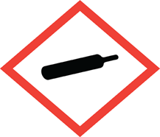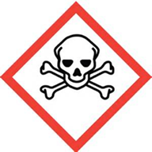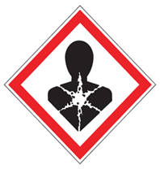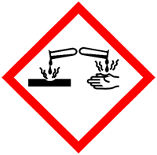

FIRST AID
Contact with rapidly expending gas can cause burns or frost bites.

Eyes: Check and remove contact lenses. Flush eyes with plenty of water for 15 min. Seek medical attention.
Skin: Rinse with plenty on water, warm up the frozen tissues. Seek medical attention.
Inhalation: Remove person to fresh air, rest in half-upright position. Seek medical attention.
Ingestion: Do not induce vomiting. Seek medical attention

DIAL 911 Call REHS for more information 848-445-2550

