Standard Operating Procedure for Laboratories

ARSINE

Department: | Click here to enter text.
Principal Investigator(s): | Click here to enter text.
Lab Manager/Coordinator: | Click here to enter text.
Location of Experiment:  (Building/Room Number) | Click here to enter text.
Lab Phone: | Click here to enter text.
Office Phone: | Click here to enter text.
Emergency Contact: (Name/Phone) | Click here to enter text.

Reviewed and Approved by:

PI: (Typed Name) | Click here to enter text.
PI: (Signature and Date) |  | Click here to enter a date.
Lab Manager: (if PI unavailable) |  | Click here to enter a date.

Hazardous Material Use and Management

Hazardous Material(s) Used: (wt./volume) | ARSINE:  Maximum amount allowed without PI approval:
Hazardous Material Storage Location: | Store container/ cylinder in a cool, well-ventilated area like gas cabinet with exhaust. Gas cylinders should not be stored within 20 feet of oxygen and other oxidizing gas cylinders. Keep containers tightly closed. Store in an area without drain or sewer access. Avoid possible sources of ignition.  Designated Storage Area:
Experimental Procedure and Techniques to be Used: | Lab must have written procedure for cylinder purge, set up and swap.
Hazard Identification: (i.e., physical/health hazards) | CAS# 7784-42-1  GHS Classification: Danger, extremely flammable gas under pressure, acutely toxic, toxic to aquatic life, may cause damage to organs, may cause respiratory tract irritation.  - Arsine is a highly flammable, toxic gas and considered a pyrophoric, spontaneously ignites on contact with air.  - Contact with rapidly expanding gas may cause burn and frostbite.  - Arsine ignites on contact with chlorine at room temperature. Containers may explode when heated.  - Arsine causes hemolysis, kidney failure, heart failure and peripheral nerve system degeneration.  - Confirmed human carcinogen. May be fatal through inhalation.  OSHA PEL: TWA 0.05ppm (0.2mg/m3)  ACGIH TLV: TWA 0.005ppm  Review MSDS/SDS prior to use this chemical.
Engineering Controls: (chemical fume hood, biosafety cabinet, glove box) | Arsine should be used in an explosion-proof, ventilated area at all times. Use of closed system in a chemical fume hood or glove-box is recommended. Ground all lines and equipment used with arsine. Eyewash and safety shower must be readily available.
Protective Equipment: | Wear chemical safety goggles or in some cases a face shield to protect face from direct exposure to the gas.  Wear neoprene, butyl rubber, PVC, polyethylene or Teflon gloves.  Wear flame resistant lab coat (cotton based), long pants and closed-toe shoes.  Always check with glove manufacturer for more info.
Waste Collection/Disposal Method: | Arsine cylinders should be returned to the compressed gas distributor when emptied or no longer used. Liquefied waste should be collected in tightly closed container, in a secondary plastic containment and in a designated location inside a fume hood. Double bag dry waste. Dispose empty glass containers as hazardous waste. Affix a hazardous waste label and fill it in. Contact REHS for waste pick up:  https://halflife.rutgers.edu/forms/hazwaste.php
Spill Management: | Vapors are heavier than air. Assess the extent of danger. Help contaminated or injured person. Evacuate the spill area. Avoid breathing vapors. If possible, confine the spill to a small area using a spill kit or absorbent material. Keep others from entering contaminated area. Call 911, call REHS.
First Aid: | Eyes: Check and remove contact lenses. Immediately flush eyes with plenty of water for 15 minutes. Seek medical attention.  Skin: To avoid static discharge and gas ignition soak contaminated closing with water before removing it. Flush contaminated skin with water for 15 min. Seek medical attention.  Inhalation: Remove victim to fresh air. Call poison center, seek immediate medical attention.  Ingestion: Ingestion is unlikely as product is a gas.

Training
- Prior to conducting any work with arsine, designated personnel must be provided training specific to the hazard involved in working with the substance.
- The PI must provide his/her lab personnel with a copy of the SOP and a copy of the SDS provided with the manufacturer.
- The PI must ensure that his/her lab personnel have attended and are up to date on the appropriate laboratory safety training within the last year.

I have read and understood the content of this SOP and the SDS:

Lab Personnel  (Running the Experiment) | Date of Hands-on Training from Department | Signature of Lab Personnel
Click here to enter text. | Click here to enter text.
Click here to enter text. | Click here to enter text.
Click here to enter text. | Click here to enter text.

ARSINE

Danger, Extremely flammable gas under pressure, Acutely toxic, Toxic to aquatic life, May cause damage to organs, May cause respiratory tract irritation
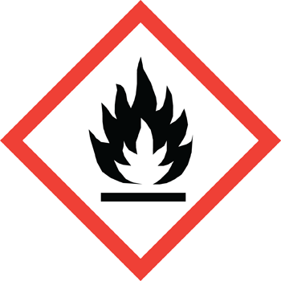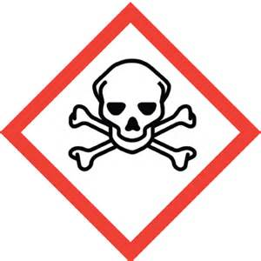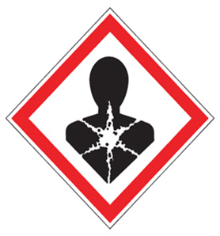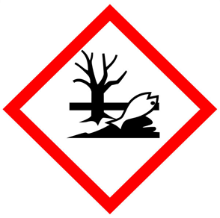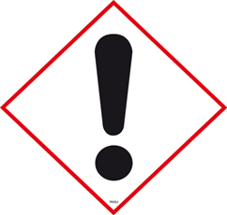

FIRST AID

Eye Contact: Immediately flush eyes with plenty of water for 15 minutes. Seek medical attention.
Skin Contact: To avoid static discharge and gas ignition soak contaminated closing with water before removing it. Flush contaminated skin with water for 15 min. Seek medical attention.
Inhalation: Remove victim to fresh air. Call poison center, seek immediate medical attention.
Ingestion: ingestion is unlikely as product is a gas.

DIAL 911 Call REHS for more information 848-445-2550

