Standard Operating Procedure for Laboratories

Aniline or Aniline Dyes (phenylamine, aminobenzine)

Department: | Click here to enter text.
Principal Investigator(s): | Click here to enter text.
Lab Manager/Coordinator: | Click here to enter text.
Location of Experiment:  (Building/Room Number) | Click here to enter text.
Lab Phone: | Click here to enter text.
Office Phone: | Click here to enter text.
Emergency Contact: (Name/Phone) | Click here to enter text.

Reviewed and Approved by:

PI: (Typed Name) | Click here to enter text.
PI: (Signature and Date) |  | Click here to enter a date.
Lab Manager: (if PI unavailable) |  | Click here to enter a date.

Hazardous Material Use and Management

Hazardous Material(s) Used: (wt./volume) | ANILINE:  Maximum amount allowed without PI approval:
Hazardous Material Storage Location: | Store in a dry well ventilated area. Opened containers must be carefully resealed. Protect from moisture and light. Avoid strong oxidizers, strong acids, toluene diisocyanate, alkalis, iron, iron salts and zinc.  Designated Storage Area:
Experimental Procedure and Lab Techniques Used:

Hazard Identification: (i.e., physical/health hazards) | CAS# 62-53-3  GHS Classification: Danger combustible, very toxic, skin sensitizer, irritant, mutagen, carcinogen, toxic to aquatic life.  - Toxic if inhaled, ingested, or absorbed through the skin.  - Causes respiratory tract, skin and eye irritation.  - Volatile and can ignite readily.  OSHA PEL: TWA 5ppm (19 mg/m3), skin  ACGIH TLV: TWA 2ppm (7,6mg/m3), skin  Review MSDS/SDS prior to work with this chemical.
Engineering Controls: (chemical fume hood, biosafety cabinet, glove box) | All work with Aniline must be performed in a glove box or in a chemical fume hood with adequate ventilation.  Safety shower and eyewash must be easily accessible.
Protective Equipment: | Avoid contact with skin, eyes and clothing.  Nitrile gloves are sufficient for short term use.  Wear tight-fitting safety glasses/ goggles to protect eyes.  Wear full length lab coat, long pants and closed-toe shoes.  Wash hands before breaks and immediately after handling Aniline.  Always check with glove manufacturer for more info.
Waste Collection/Disposal Method: | Collect waste in tightly closed containers, in secondary containment and in a designated location. Affix and complete hazardous waste label. Contact REHS for waste pick up:  https://halflife.rutgers.edu/forms/hazwaste.php
Spill Management: | If you have training you can assist in the clean-up. Use appropriate PPE and use inert material (vermiculate, send or earth). Double bag spill waste in clear plastic bag.  If a spill happened outside fume hood, on floor, on bench or outside the lab contact REHS for clean up or call 911.
First Aid: | Eyes: Check and remove any contact lenses. Immediately flush eyes with running water for at least 15 minutes, seek medical attention.  Skin: Remove contaminated closing and shoes. Immediately flush skin with plenty of water. Cover irritated skin with emollient/ anti-bacterial cream. Seek medical attention.  Inhalation: Remove person to fresh air, if breathing is difficult give oxygen. Seek immediate medical attention.  Ingestion: Do not induce vomiting, call physician immediately.

Training

- Prior to conducting any work with aniline, designated personnel must be provided training specific to the hazard involved in working with the substance.
- The PI must provide his/her lab personnel with a copy of the SOP and a copy of the SDS provided with the manufacturer.
- The PI must ensure that his/her lab personnel have attended and are up to date on the appropriate laboratory safety training within the last year.

I have read and understood the content of this SOP and the SDS:

Lab Personnel  (Running the Experiment) | Date of Hands-on Training from Department | Signature of Lab Personnel
Click here to enter text. | Click here to enter text.
Click here to enter text. | Click here to enter text.
Click here to enter text. | Click here to enter text.

ANILINE or ANILINE DYES

Danger, combustible, very toxic, skin sensitizer, irritant, mutagen, carcinogen, toxic to aquatic life.

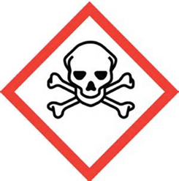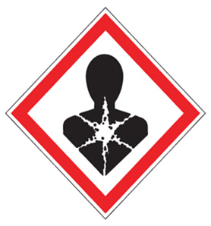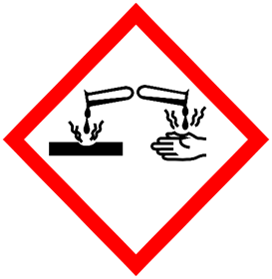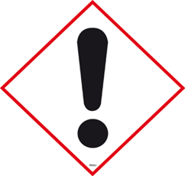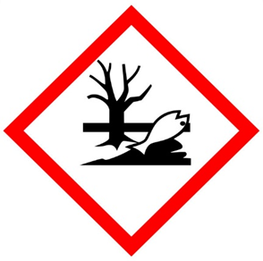

FIRST AID

Eyes: Immediately flush eyes with running water for at least 15 minutes, seek medical attention.
Skin: Remove contaminated closing and shoes. Immediately flush skin with plenty of water. Cover irritated skin with emollient/ anti-bacterial cream. Seek medical attention.
Inhalation: Remove person to fresh air, if breathing is difficult give oxygen. Seek immediate medical attention.
Ingestion: Do not induce vomiting, call physician immediately.

DIAL 911 Call REHS for more information 848-445-2550

