PICK-UP and/or Delivery Box Request

NOTE – If you used Infolinx previously please be sure that you followed the INITIAL LOG IN UPDATE “how to” process prior to picking up/requesting a box.

- Go to Gimmal at https://rutgers.gimmal.com- log in and go to the Boxes tab for Box requests.

- Search for the box by using the quick search fields at the top of the screen (gray area below the tabs) .

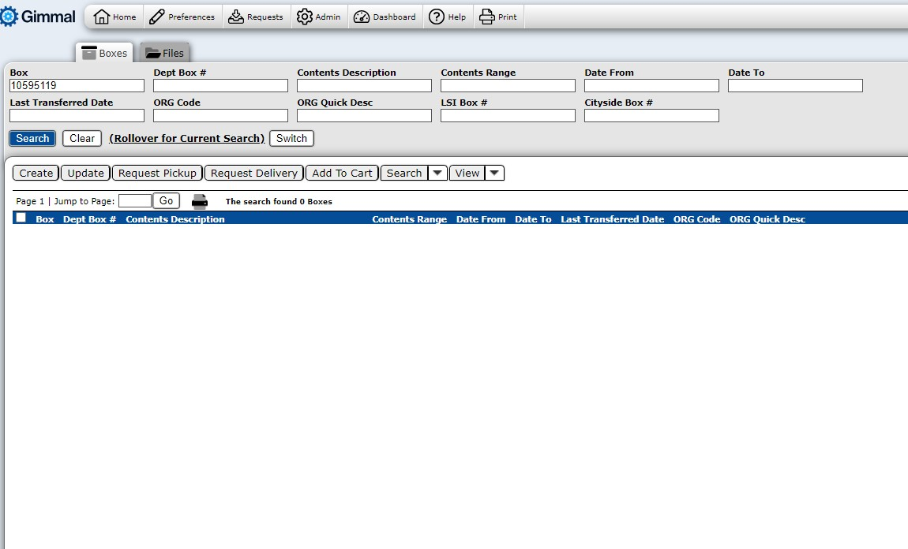
  - If you know the box bar code number, simply enter it into the box number field.
  - If you don’t know the box bar code number, you can search the database by using the other most commonly used search fields. Some tips when using quick search:
    - You can search on as many fields as you need to.
    - Enter the information into the associated field, and either click the blue Search button or press Enter on your keyboard.
    - Wild Card searches - If you’re not sure of a complete box number, department name, etc., use the wildcard (%) at the beginning or end of a search term to allow you to use partial words/numbers. For example:
      - 123% will return results with any number that starts with 123 in that field.
      - %456 will return results with any number that end in 456 in that field.
      - %2345% will return results with any number that has 2345 in the middle of the number.
      - The same rule applies to alpha search terms.
      - A percent sign with no other information will return all boxes available to you in Gimmal.
    - For a more refined search, click on the grey Search and View button. This will take you to a page that looks similar to the New Box Create view. Enter any information you would like to use in the search and click Execute. The results will display on the home page.
    - When there are multiple search results, you have the ability to sort the data by any of the column headings by simply clicking on that heading. If you click a single time on the heading, items will sort in an ascending order. If you click a second time on the same column heading, items will sort in a descending order.

- Select the box (or boxes) you wish to request by clicking on the box located to the left of the box number (a checkmark will populate the box once it is selected).

- IF YOU ARE SENDING/RETURNING BOXES TO THE UNIVERSITY RECORDS CENTER YOU SELECT REQUEST PICK-UP.

- IF YOU ARE REQUESTING BOXES TO BE SENT TO YOUR DEPARTMENT YOU SELECT REQUEST DELIVERY.

(SEE SCREENSHOT BELOW)

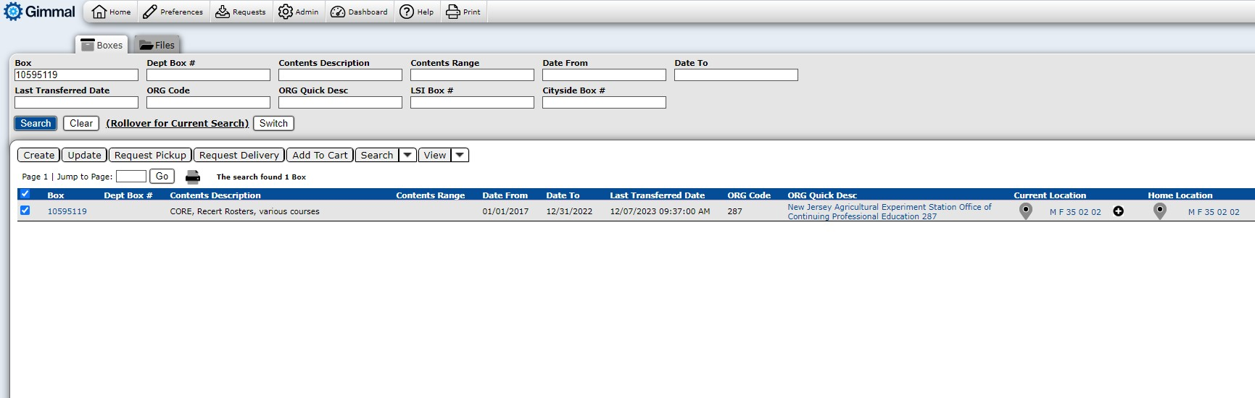

  - On the REQUEST ITEMS PAGE -- A list of the boxes you are requesting will appear at the top of the screen. If you wish to remove any of the boxes from your order, click the REMOVE link located just to the left of the box number.
  - The next section should be populated with your name and delivery location. Please confirm the information is current and accurate.
    - If you wish to make changes to the address or have the boxes picked up or delivered to/from another person at a different location, please indicate all changes in the COMMENTS section. Please do not use the SEARCH button.
  - In the COMMENTS section, you can communicate any information about the request or the delivery or pick-up of the requested items (for example, “elevator closed 12-1pm”, “deliver to Mary Smith at B-401”, etc).

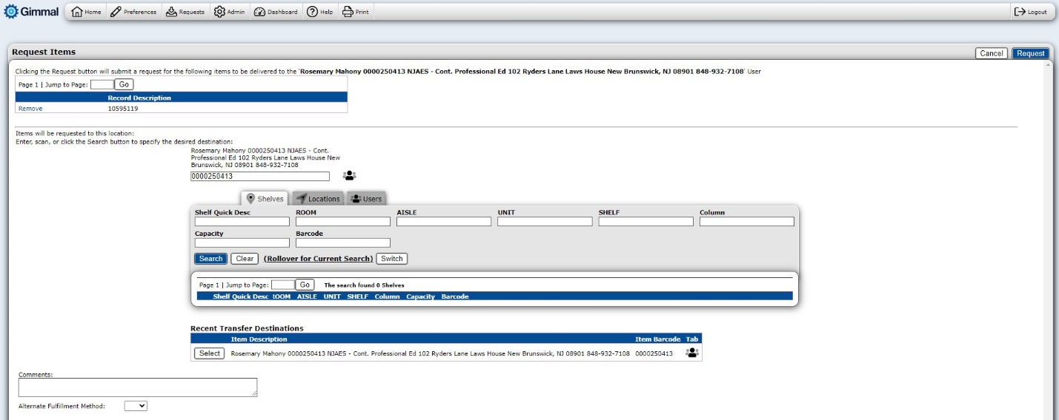
  - Please disregard anything below the COMMENTS Box.
  - To place the request for delivery, click the blue REQUEST button located at the top right portion of your screen.
    - A confirmation page with your order should appear on the next screen.
  - You can view confirmation of your request through your DASHBOARD.

