GIMMAL
Initial Log-in update – Previous Infolinx users ONLY

NEW WEBSITE ADDRESS
https://rutgers.gimmal.com
- After your initial log in you will need to update your location information.
- On the bottom of the page please COPY and SELECT the 10 digit USER BARCODE # located next to your name (Please see screenshot).
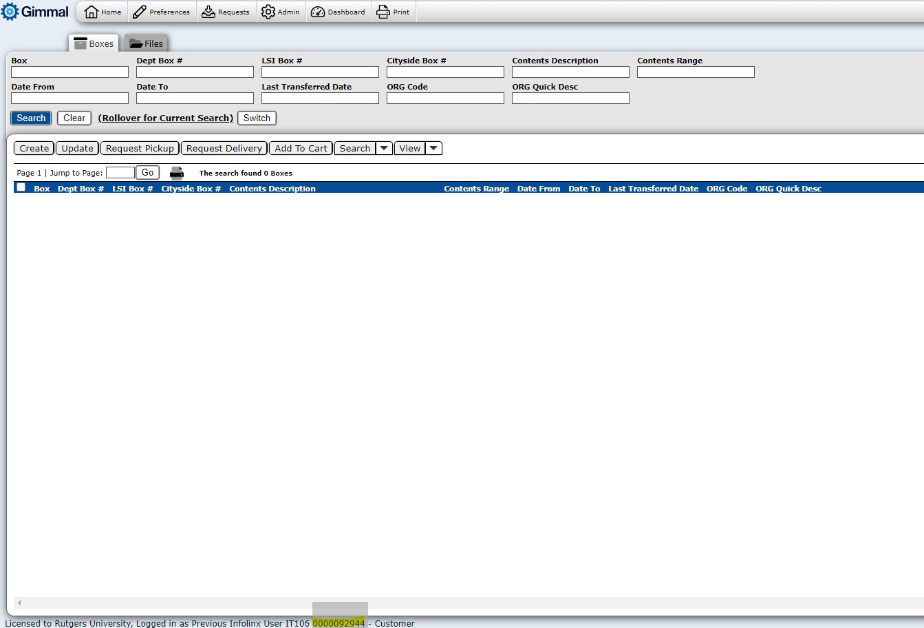
- Please click on the DASHBOARD icon on the top of the page (see screenshot for visual assistance)
  - Select the Preferences bar on the left hand side of the pop up screen
  - Scroll down so that the FILES and BOXES (blue ribbon) is showing
  - PASTE your 10 digit USER BARCODE # into the following boxes
    - File - Default current location
    - Files - Default request location
    - Boxes - Default current location
    - Boxes - Default request location
  - Click on the Save button in the top right corner of your pop-up window
  - Click on the X to close the pop-up window
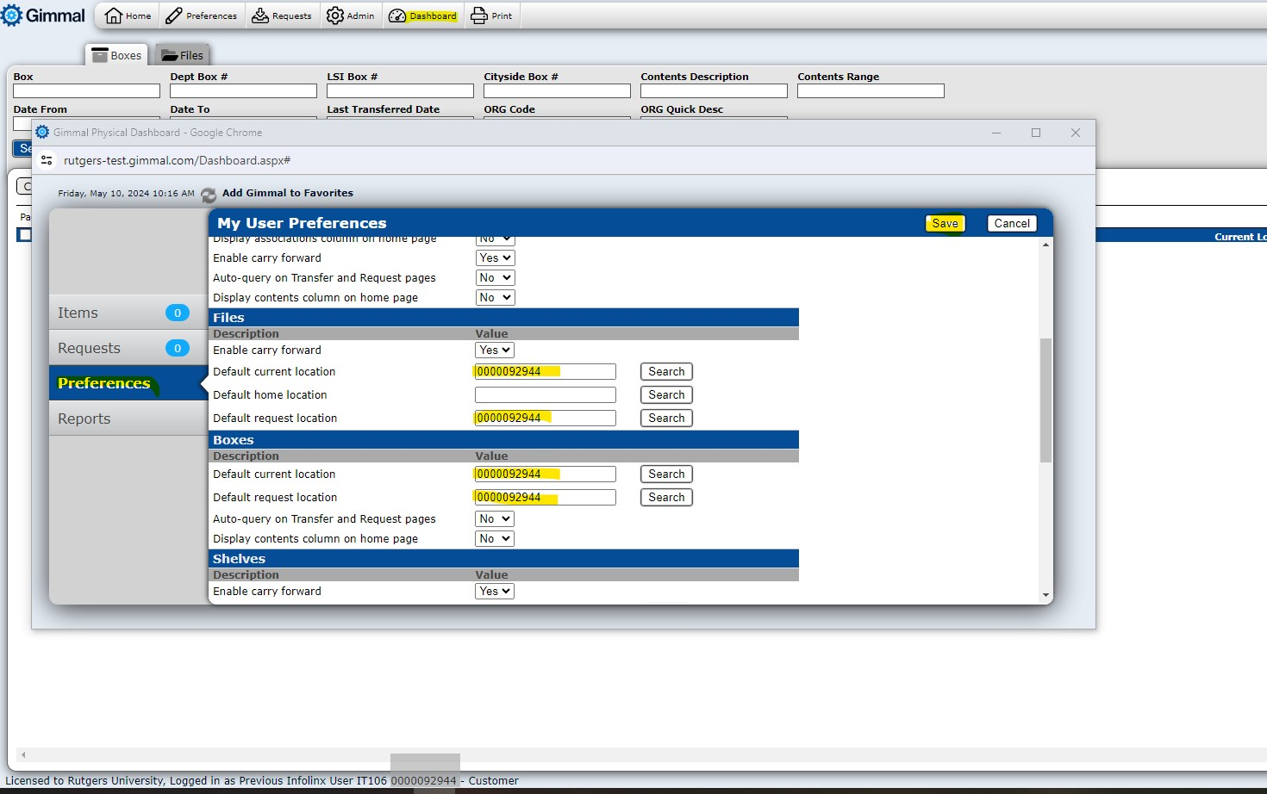
Paste your User # into the 4 highlighted boxes
- You are now ready to use the application.

