File Request : DELIVERY

NOTE – If you used Infolinx previously please be sure that you followed the INITIAL LOG IN UPDATE “how to” process prior to requesting a file.

- In order to request a file from a box stored at the Records Center – a file needs to be “created” in the Gimmal system.
- Go to Gimmal at https://rutgers.gimmal.com- log in and go to the Boxes tab for Box requests or NEW file requests.

- Search for the box by using the quick search fields at the top of the screen (gray area below the tabs) .

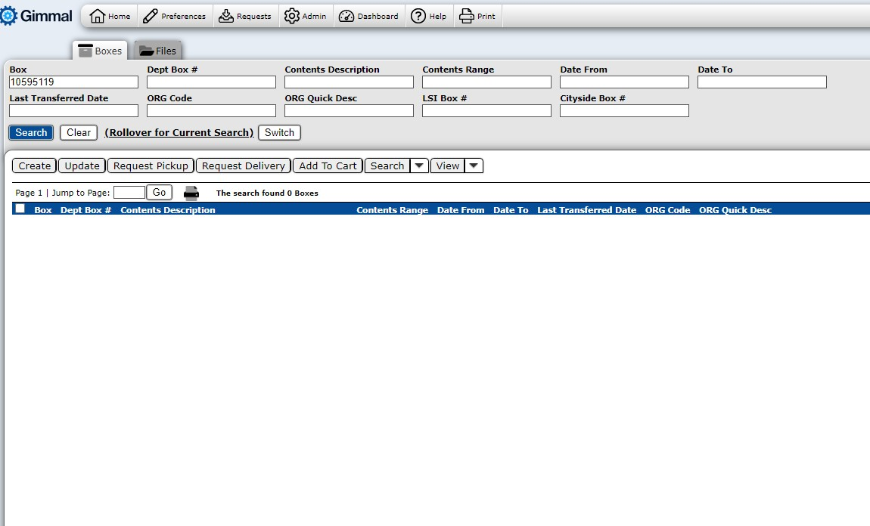
  - If you know the box bar code number, simply enter it into the box number field.
  - If you don’t know the box bar code number, you can search the database by using the other most commonly used search fields. Some tips when using quick search:
    - You can search on as many fields as you need to.
    - Enter the information into the associated field, and either click the blue Search button or press Enter on your keyboard.
    - Wild Card searches - If you’re not sure of a complete box number, department name, etc., use the wildcard (%) at the beginning or end of a search term to allow you to use partial words/numbers. For example:
      - 123% will return results with any number that starts with 123 in that field.
      - %456 will return results with any number that end in 456 in that field.
      - %2345% will return results with any number that has 2345 in the middle of the number.
      - The same rule applies to alpha search terms.
      - A percent sign with no other information will return all boxes available to you in Gimmal.
    - For a more refined search, click on the grey Search and View button. This will take you to a page that looks similar to the New Box Create view. Enter any information you would like to use in the search and click Execute. The results will display on the home page.
    - When there are multiple search results, you have the ability to sort the data by any of the column headings by simply clicking on that heading. If you click a single time on the heading, items will sort in an ascending order. If you click a second time on the same column heading, items will sort in a descending order.

- Select the box you wish to request a file from and by simply clicking on the blue Box# hyperlink. (See screenshot below)

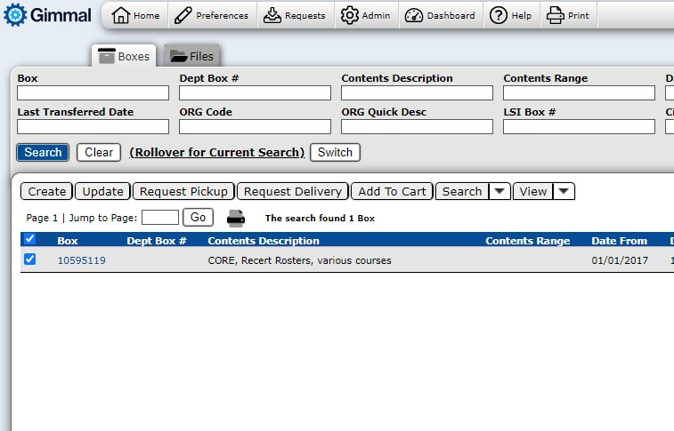

- You are now on the VIEW A BOX page (See screenshot below)
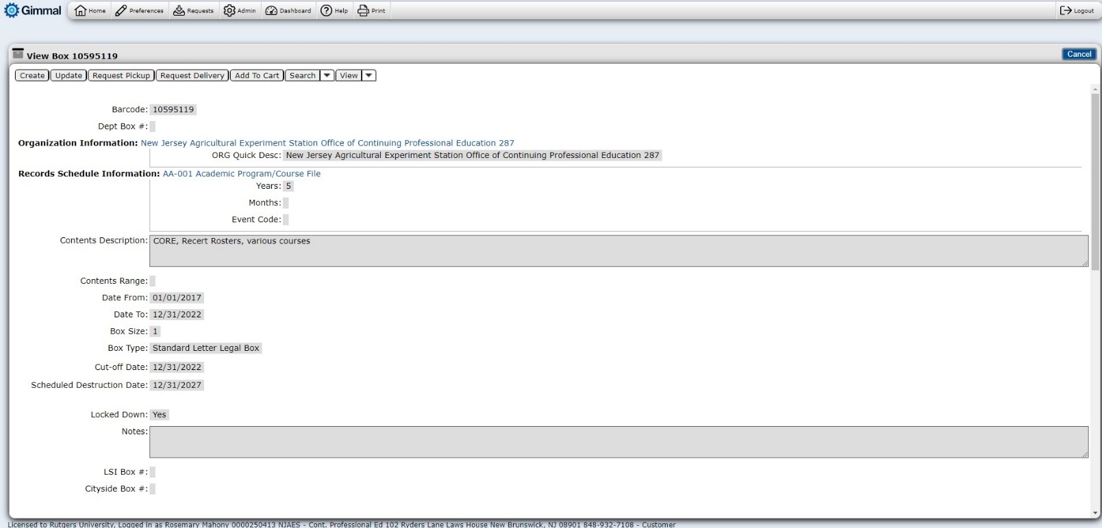

- Scroll down to locate see the Box Contents/File icon
  - Select the blue Create link which will take you the CREATE FILE page (see screenshot below)

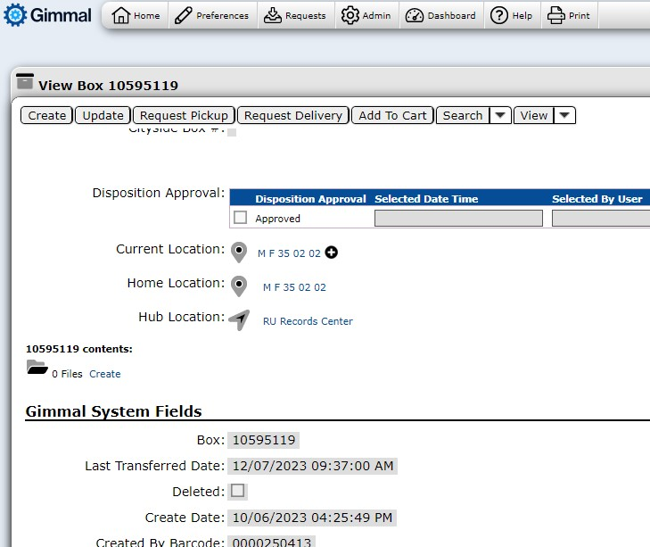
  - Type in the file name you desire in the File Number/Name: Box
    - A File Date: can be entered if applicable.
  - Click the SAVE & VIEW button in the top right corner of the screen. (See screenshot below)
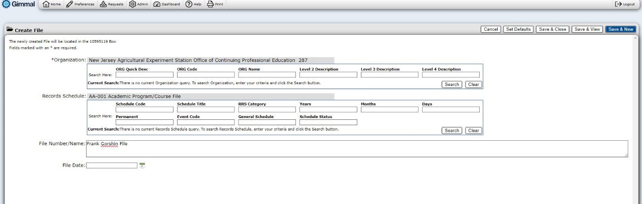
  - To request the file click on the REQUEST DELIVERY button. (See screenshot below)
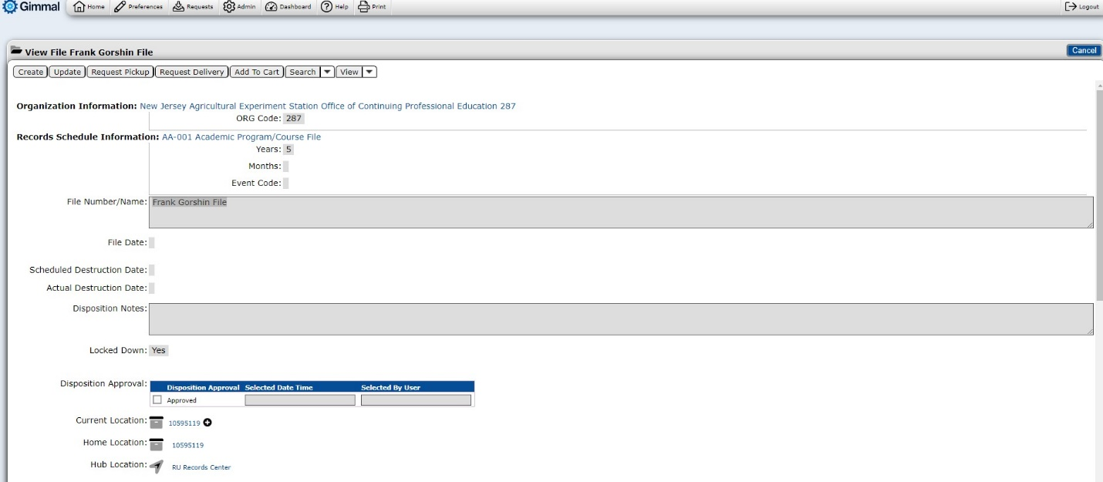
- If you require a special request such as;
    - ON SITE REVIEW - If you would like to have your boxes pulled and placed in one of the audit rooms located at the Records Center
    - SCAN ON DEMAND - If you would like the file scanned and electronic delivered to you.
    - RUSH REQUEST - If you need the files priority delivered
please indicate your special request in the COMMENTS Box (indicated below)
NOTE – ALSO SEND AN EMAIL to the Records Management staff indicating your desire for a priority RUSH REQUEST (email: recordsmanagement@ipo.rutgers.edu)

- Please disregard anything the directly above/below the COMMENTS Box.
- To place the request for delivery, click the blue REQUEST button located at the top right portion of your screen. (See screenshot below)
    - A confirmation page with your order should appear on the next screen.
- You can view confirmation of your request through your DASHBOARD.
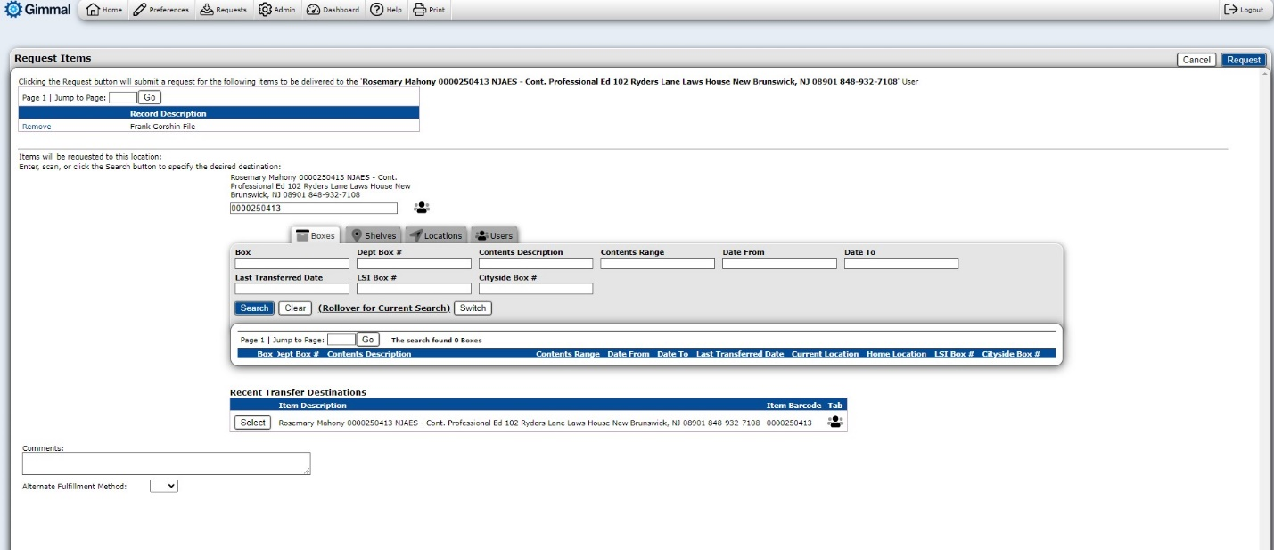
Disregard this section

