Creating a new box into Gimmal

NOTE – If you used Infolinx previously please be sure that you followed the INITIAL LOG IN UPDATE “how to” process prior to creating a new box.

- Pack your records in Rutgers Records Management approved boxes and affix unique bar code labels.
  - Boxes can be ordered from the RURC (Rutgers University Records Center). Email your request for storage boxes to recordsmanagement@ipo.rutgers.edu. The boxes will be sent to you along with a corresponding number of unique bar coded labels. Additional labels (without boxes) can also be ordered.
- Again, if you were already set up previously in Infolinx, and have not already done so, please follow the ”how-to” instructions of setting up your location in your Dashboard.

- Add a box (or boxes) to the Gimmal system.
  - Goto Gimmal at https://rutgers.gimmal.com, log on and go to the Boxes tab.
  - Click on the CREATE button

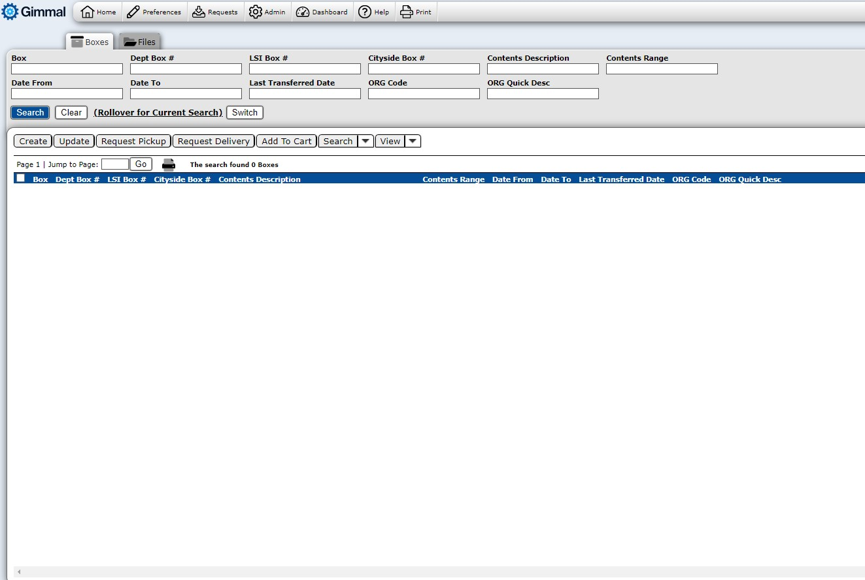

Enter information in the following categories:
  - *Box Barcode – (Required) Enter the unique box number from the bar coded label that has been placed on the box
  - Dept Box # - (Optional) – If your department uses a numbering system that you would like to be able to search on in addition to the unique box number, enter that number in this field.
  - Organization – (Required) – The owner code(s) that were defined at the time of set up will appear in this section
    - Select the SEARCH button in the Organization section (right side-see picture below)
    - If you were set up with more than one code, a list of those codes will appear under the blue Org Quick Description ribbon. Select the desired owner code by clicking the round radio button. Once selected, the owner code and description will populate the Organization field.
    - If the correct owner code is not listed or if you have any questions, please contact the Records Center at recordsmanagement@ipo.rutgers.edu.
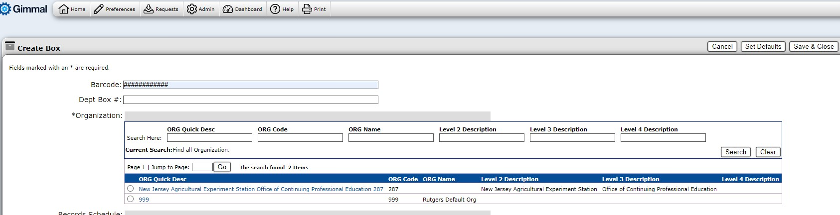

  - Records Retention Schedule – (Required) – Based on the Owner code that was selected in the previous step, a list of General (University wide) and Department (department specific) Records Retention Schedules will display under the blue Retention Schedule Quick Description ribbon.
    - Select the schedule that matches the record type packed in the box (there might be more than 1 page to review)
    - If the record type is not listed or if you have any questions, please contact the Records Center at recordsmanagement@ipo.rutgers.edu.
  - Contents Description – (Required) – Enter a brief description of the contents of the box (for example, 2010 School of Pharm. Graduates, Patient Files purged Oct 2009, 2008 Closed Files, etc)
    - Be sure to use the Contents Date Range and Contents Range fields to properly identify the contents of the box
    - If the box does not have a logical sequence, specific file level information can be entered. You can cut and paste already created inventories into this category. Data that is entered can be key word searched later.
  - Contents Range – (Optional) – If your box has a logical alpha or numeric sequence, enter the first and last file in this field
    - For example, if the box contains files 100 to 150, enter 100-150. If the box contains files Adams to Jones, enter the full names or abbreviate with ADA-JON.
  - Contents Date Range (DATE FROM:/DATE TO:) – (Required) – Enter the date range of the records that are being stored in the box. It is very important that this field is entered so that the scheduled destruction date of the box can be calculated.
    - Format: MM/DD/YYYY
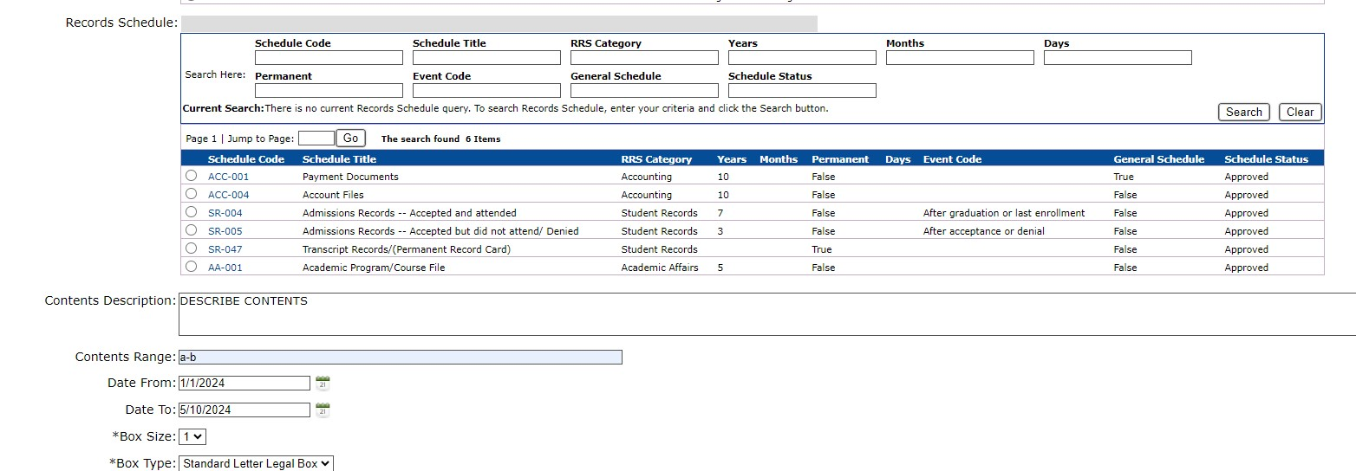

  - THE FOLLOWING CATERGORIES ARE automatically inputted (no need to adjust)
    - Box Size
    - Box Type

  - THE FOLLOWING CATERGORIES ARE NOT NEEDED FOR USER INPUT
    - Cut-off date
    - Notes
    - LSI Box #
    - Cityside Box #

SAVING NEWLY CREATED BOX IN GIMMAL

Once you have completed the entry for the box, you can click one of 3 buttons located at the top right portion of your screen:
    - Save & New – Select if you wish to save the new box just created and you wish to create a second box.
      - All of the information from the box just created will auto-populate so be sure to change any information for the new box that you are creating from the box just created, including the Box Barcode number.
    - Save & View – Select if you wish to save the new box just created and you wish to view the information.
    - Save & Close – Select if you wish to save the new box just created and have completed entry. You will be taken back to the Box data view.
